Game Project 1

<Mastermind Game>

CSC 17A- 42824

Heidy Tamayo

Date: 05/04/16

**Introduction**

Title: Mastermind Game

Mastermind is played online where there is a table showing four empty slots allowing the user to enter a round marble color. The colors to choose from are red, blue, black, green, white, orange, brown and yellow. The computer generates its own colors and the user must guess which of the colors the computer has picked. The user types in the color in order from left to right (ex: blue red green black) and is then told if they have made a wrong guess. The user is asked the name they would associated with the game. The user is allowed ten turns to win the game but can have more than ten that if they like. However, they will see a statement after the tenth try that they have lost the game. If they have guessed wrong, the user is then asked if they would like a hint. If yes, the program gives a hint indicating if there is a color they have inputted in the correct spot and correct color by outputting “X” and if they just have the correct color an “0” is outputted. Otherwise, it is left blank. The user can keep guessing the colors the computer has generated up to the end of the number of tries the user inputted or if the user guesses all the colors correctly. If the user cannot guess the colors, the message displays they have lost the game. If the user has won, the percent accuracy is generated along with the number of tries it took the user to complete the game. At the end of the game whether win or lose, the computer asks the user if they would like to play again or end the program.

**Summary**

Project size: 580 lines

Concepts Utilized from Chapters 9-12:

* Structures
* Pointers with arrays
* Arrays of structures
* Structures passed through functions
* String Objects and class
* Reading a binary file
* Opening a binary file
* Allocated memory
* Function that returns structure objects
* Inputting into a structure variable and outputting

Concepts Utilized:

* Character data types
* Integer data types
* Float data types
* Boolean data types
* Ternary operators
* Single if-else statements
* Expanded if-else statements (if, else if, else)
* Formatting (setting the precision of a decimal)
* Single if
* Switch decision
* While loops
* Do-while loops
* For loops
* File (opening a file containing the outputted results)
* Random number seed
* pass by value calling a value to a function and then outputting it
* pass by reference where the & sign comes in the function
* defaulted parameters
* returning primitive data types
* outputted to file
* arrays
* parallel arrays
* searching required
* 2D arrays
* passing 2D arrays into/out of function

I improved the game by not making it so obvious when the user has inputted the correct color and in the correct spot. This is by the output of the hint says an “X” but it doesn’t indicate which one is in the correct spot just that one is correct. Another improvement is indicating the color that is correct but not in the right spot. I would like to improve the game by making a chart for the user to make it easier to use the process of elimination. Also if possible be allowed to save the user’s information in a separate memory so that if the user would like to see their information in the future they can.

**Description**

The main point of the program is to have the user think through the game based on the hints the computer generates and allow the user to guess the colors the computer has generated randomly through the process of elimination.

**Flowchart**

The flowchart was too big to fit into one screen shot and have is legible so I have put the whole flowchart and sections to show each portion.

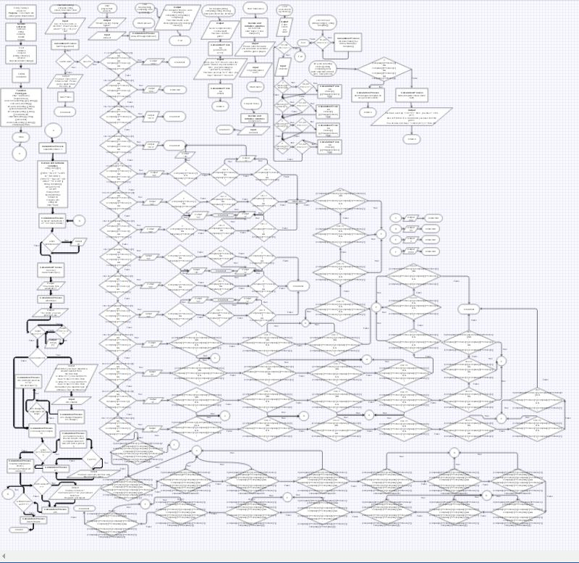

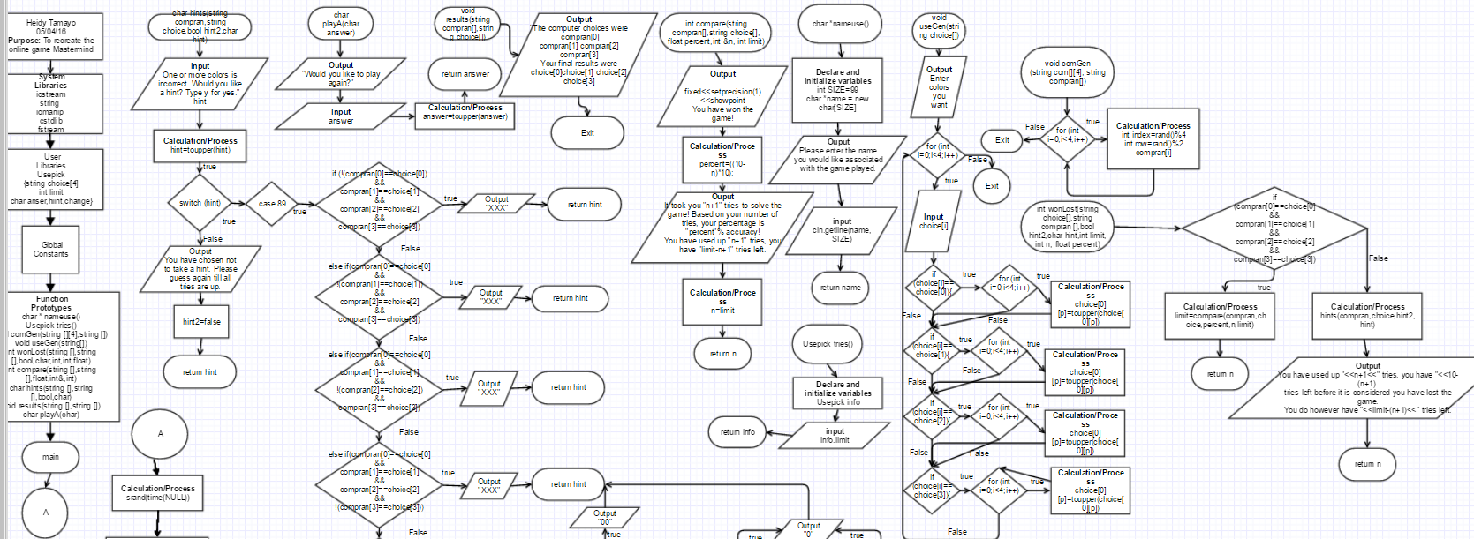

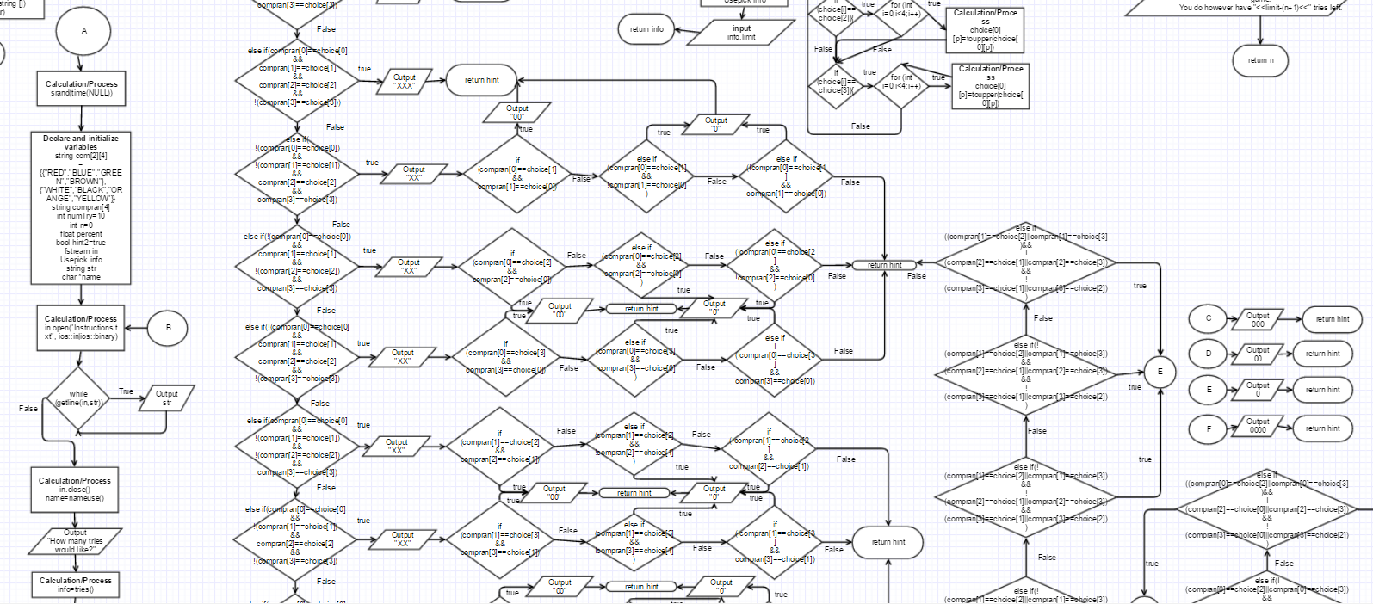

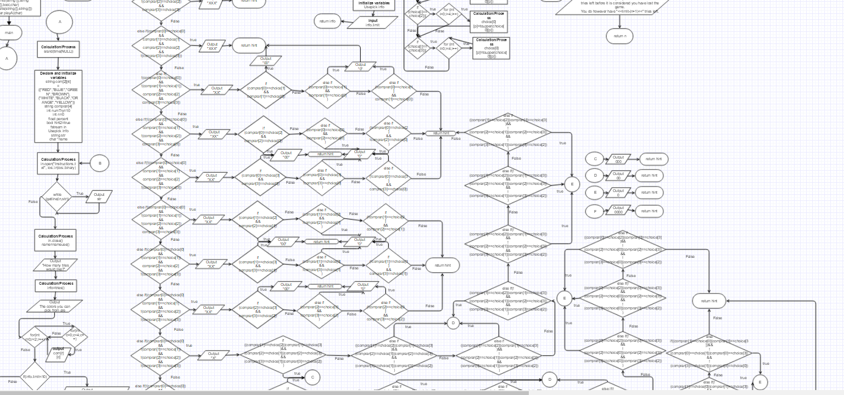

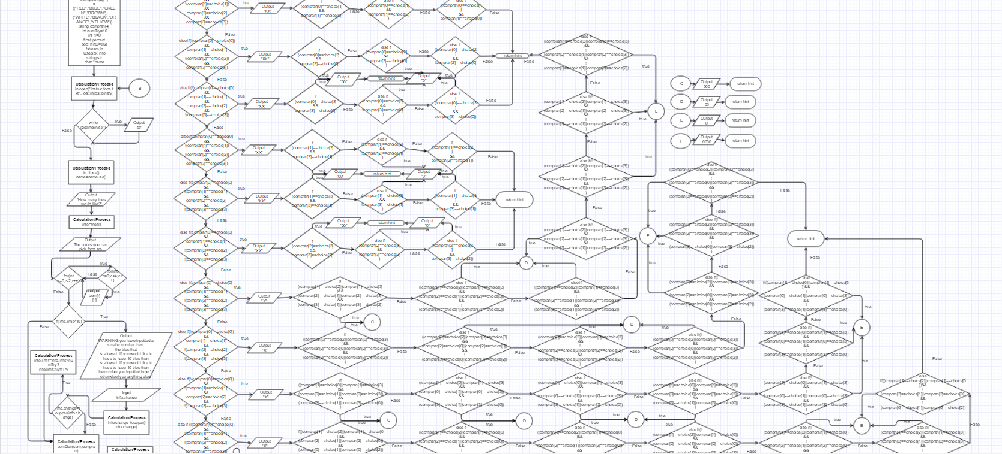

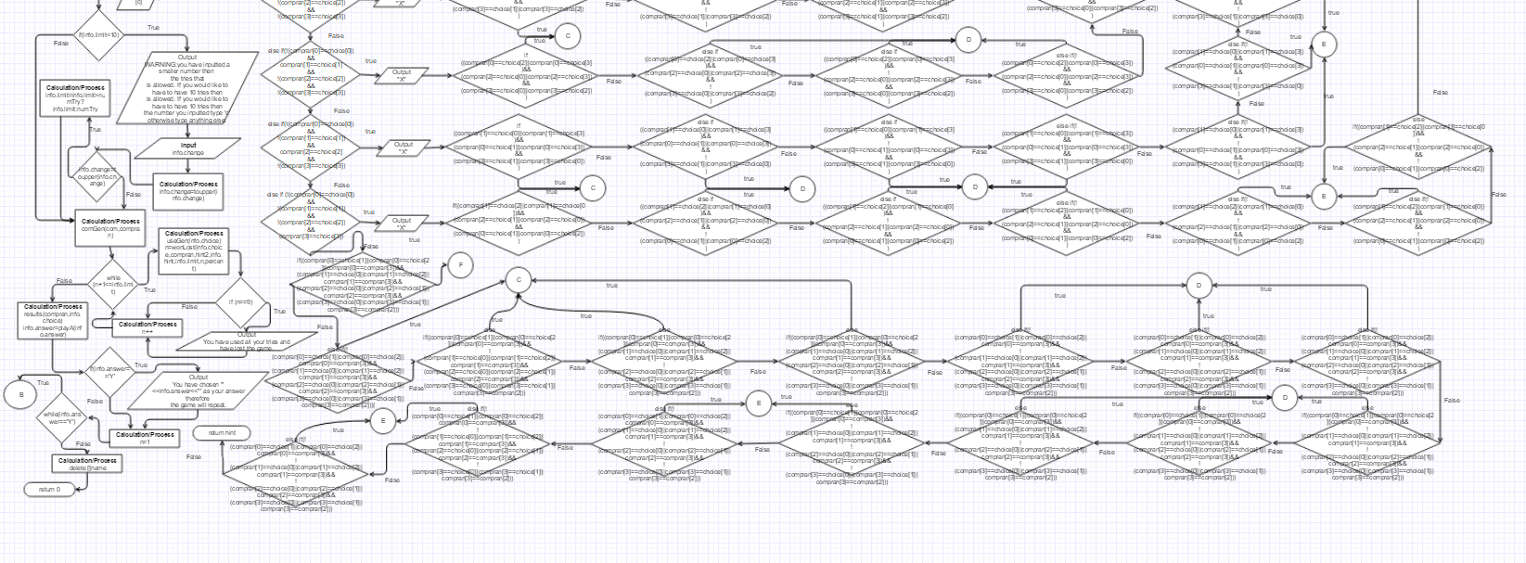

**Pseudo Code**

Declaring the variables

Opens the file to read the directions

Asks user for the name and number of tries

Tells the user how many colors to pick from

If the number of tries is less than ten conforms with the user if that is what they want

Generates the computer’s colors

Begins the tries the user has inputted and gets the user’s colors

Compares the user’s colors to the computer

Determines if the user is correct or incorrect

After ten turns it is considered they have lost

Shows the results of the user

Asks the user if they would like to play again the game

**Major Variables**

|  |  |  |
| --- | --- | --- |
| **Type** | **Variable Name** | **Description** |
| int | limit | The limit the user inputs |
| string | Compran[4] | An array of 4 of the computer pick |
| string | Choice[4] | An array of 4 of the choice of the student |
| string | Com[2][4] | The 8 choice the computer picks from randomly |
| Int | NumTry=10 | The number of tries the user has before they lose the game |
| char | answer | The answer the user inputs |
| Char | hint | Determines if the user will like a hint |
| int | n=0 | Increments the while loop goes through |
| Float | Percent | The percentage the user gets if they win the game |
| Bool | Hint2 | Statement to determine if true and allow the output |
| fstream | In | Opens the file to read the instructions to the user |
| Usepick | Info | Allows the structure variables to be brought into main |
| String | Str | Brings the direction to main by transferring from the file |
| Char | *name | Pointer that allows the user to input the name they wanted associated with the game |

**Constructs**

|  |  |
| --- | --- |
| **Chapter** | **Type** |
| 2 | Char |
|  | Int |
|  | Float |
|  | Bool |
|  | Ternary operator |
| 4 | If |
|  | If else statement |
|  | If else if |
|  | switch |
| 5 | while |
|  | Do-while |
|  | File |
|  | random |
| 6 | Pass by value |
|  | Defaulted parameter |
|  | Returning primitive data types |
|  | functions |
| 7 | Parallel Arrays |
|  | Arrays |
|  | 2D Arrays |
| 9 | Pointers with arrays (line 30,145,148) |
|  | Allocated memory (line 148) |
| 10 | String objects/classes (lines 20, 65,184,191) |
| 11 | Array of structures (lines 20, 109, 191) |
|  | Structures types passed into functions (lines 109,112,126) |
|  | Structures (line 18) |
|  | Function that return structure object variables (line 37, 82, 159) |
|  | Inputting/Outputting a structure variable (lines 82, 97, 109, 130, 162) |
| 12 | Reading a binary file (line 73-74) |
|  | Opening a binary file (line 71) |

**Program**

/*

* File: main.cpp

* Author: Heidy Tamayo

* Created on May 2, 2016, 3:17 PM

* Purpose: Playing the game Mastermind

*/

//System Libraries

#include <iostream> //I/O

#include <string> //string

#include <iomanip> //Formatting

#include <cstdlib> //srand and rand function

#include <fstream> //File I/O

using namespace std;

//User Libraries

struct Usepick

{

string choice[4];//The 4 colors the user chooses

int limit;//The limit the user inputs

char answer, hint,change;//The response of whether the user would like to

//play again,take a hint, or change their number of

//tries

};

//Global Constants

//Functional Prototypes

char * nameuse();//Function to ask the user for the name

Usepick tries();//The number of tries the user would want

void comGen(string [][4],string []);//Function to generate the 4 random colors

//from the computer

void useGen(string[]);//Function to allow the user to enter their four colors

int wonLost(string [],string [],bool,char,int,int,float);//Function to determine

//if the user has won or

//Lost

int compare(string [],string [],float,int&,int);//Comparison of the computer

//generated and the users

char hints(string [],string [],bool,char);//hints the user may have if they

//choose to

void results(string [],string []);//Displays the results of the game

char playA(char);//Function to ask the user if they would like play again

//Execution Begins Here

int main(int argc, char** argv) {

//Set the random number seed

srand(time(NULL));

//Declare and initialize variable

string com[2][4]={{"RED","BLUE","GREEN","BROWN"},

{"WHITE","BLACK","ORANGE","YELLOW"}};//Array that the

//computer picks from

string compran[4]; //The 4 colors the computer generates

int numTry=10;//The number of tries the user gets before it is considered

//they have lost.

int n=0;//The increments to indicate the turns allowed before the user loses

float percent;//The intervals of the turns, the percentage of the accuracy

bool hint2=true;//Statement to determine if the statement is true

fstream in;//File output

Usepick info;//Brings the information to the structure

string str;//String that is being used to bring the file to the program

char *name;//Ask for the users name

//Do while loop to see if the user would like to play again

do

{

in.open("Instructions.txt", ios::in|ios::binary);//Opens the file

while (getline(in,str)){

cout<<str;}//reads the file into the program

in.close();//Closes the file

cout<<endl<<endl;

name=nameuse();//Function for user to write their name

cout<<"How many tries would like?"<<endl;

info=tries();//Asking the user how many tries they would like

//Color choices avaliable in for loop

cout<<"The colors you can pick from are"<<endl;

for(int r=0;r<2;r++){

for(int c=0;c<4;c++)

cout<<com[r][c]<<" ";

}

//If statement to warn the user the number of tries they have implemented

if(info.limit<10){

cout<<endl<<endl<<"WARNING:you have inputted a smaller number then ";

cout<<"the tries that"<<endl;

cout<<"is allowed. If you would like to have to have 10 tries then"<<endl;

cout<<"the number you inputted type 'c' otherwise type anything else."<<endl;

cin>>info.change;

info.change=toupper(info.change);//Changes the letter choice to uppercase

//If statement to change the number of tries if the user wishes to

if(info.change=='C'){

info.limit=info.limit>numTry?info.limit:numTry;//Ternary operator

}

}

comGen(com,compran);//Determining colors by the computer

//while loop to generate the number tries for the user

while (n+1<=info.limit){

useGen(info.choice);//The color the user wants to pick

//Function to determine if the user has won or lost the game

n=wonLost(info.choice,compran,hint2,info.hint,info.limit,n,percent);

//if statement to indicate the user has used up the ten turns they

//to solve the same is over and is now considered they lost

if (n==9){

//Output of results after all tries have been used up

cout<<"You have used all your tries and have lost the game."<<endl<<endl;}

n++;

}

//Function that determine the results of the user

results(compran,info.choice);

//Function that determines if the user would like to play again

info.answer=playA(info.answer);

//If statement if the user decides to play again.

if(info.answer=='Y'){

cout<<"You have chosen '"<<info.answer<<"' as your answer therefore ";

cout<<"the game will repeat."<<endl;}

n=1;//Resets the increment of tries

}while(info.answer=='Y');

delete []name;//Deletes the allocate memory of the user name

//Exit stage right

return 0;

}

//000000011111111112222222222333333333344444444445555555555666666666677777777778

//345678901234567890123456789012345678901234567890123456789012345678901234567890

// Allows the user to enter the name to associate with the game

//******************************************************************************

char *nameuse()

{

int SIZE=99;//Creates the size the user can enter

char *name = new char[SIZE];//allocates memory for what the user inputs

//Asks for the users name

cout<<"Please enter the name you would like associated with the game played."<<endl;

cin.getline(name, SIZE);

return name;

}

//000000011111111112222222222333333333344444444445555555555666666666677777777778

//345678901234567890123456789012345678901234567890123456789012345678901234567890

// Allows the user to enter the number of tries

//******************************************************************************

Usepick tries()

{

Usepick info;

cin>>info.limit;

return info;

}

//000000011111111112222222222333333333344444444445555555555666666666677777777778

//345678901234567890123456789012345678901234567890123456789012345678901234567890

// Generates the computer's random values

//******************************************************************************

void comGen (string com[][4], string compran[])

{

cout<<endl;

for (int i=0;i<4;i++)

{

int index=rand()%4;//Generates a number 1-4 for the computer pick

int row=rand()%2;//Generate a number 1-2 for the computer pick

compran[i]=com[row][index];//Generates the computer pick

cout<<compran[i]<<" ";//DELETENOW

}

}

//000000011111111112222222222333333333344444444445555555555666666666677777777778

//345678901234567890123456789012345678901234567890123456789012345678901234567890

// Gets the four choices the user inputs

//******************************************************************************

void useGen(string choice[])

{

cout<<endl<<"Please pick your colors you would want displayed going from"<<endl;

cout<<"left to right."<<endl;

//Output request the user to enter the 4 colors

for (int i=0;i<4;i++){

cin>>choice[i];

//If statement to uppercase the users choices

if (choice[i]==choice[0]){

for (int p=0;p<choice[0].size();p++){

choice[0][p]=toupper(choice[0][p]);}

}

if (choice[i]==choice[1]){

for (int p=0;p<choice[1].size();p++){

choice[1][p]=toupper(choice[1][p]);}

}

if (choice[i]==choice[2]){

for (int p=0;p<choice[2].size();p++){

choice[2][p]=toupper(choice[2][p]);}

}

if (choice[i]==choice[3]){

for (int p=0;p<choice[3].size();p++){

choice[3][p]=toupper(choice[3][p]);}

}

}

}

//000000011111111112222222222333333333344444444445555555555666666666677777777778

//345678901234567890123456789012345678901234567890123456789012345678901234567890

//Compares the user choices to the computer's to determine if they have won or lost

//******************************************************************************

int wonLost(string choice[],string compran [],bool hint2,char hint,int limit, int n, float percent)

{

//if else statement to determine if the user has won or not

if(compran[0]==choice[0]&&compran[1]==choice[1]&&compran[2]==choice[2]&&compran[3]==choice[3]){

{

//Gives the comparison of the user to the computer choice

limit=compare(compran,choice,percent,n,limit);

return n;

}

}

else

{

//Gives hints if the user decides to have

hints(compran,choice,hint2,hint);

cout<<endl<<"You have used up "<<n+1<<" tries, you have "<<10-(n+1)<<" ";

cout<<"tries left before it is considered you have lost the game."<<endl;

cout<<"You do however have "<<limit-(n+1)<<" tries left."<<endl;

return n;

}

}

//000000001111111112222222222333333333344444444445555555555666666666677777777778

//345678901234567890123456789012345678901234567890123456789012345678901234567890

/* Results if the user has won the game */

/******************************************************************************/

int compare(string compran[],string choice[], float percent,int &n, int limit)

{

//Output of results

cout<<fixed<<setprecision(1)<<showpoint;

cout<<endl<<"You have won the game!"<<endl;

percent=((10-n)*10);

cout<<"It took you "<<n+1<<" tries to solve the game! Based on your number ";

cout<<"of tries, your";

cout<<" percentage is "<<percent<<"% accuracy!"<<endl;

cout<<endl<<"You have used up "<<n+1<<" tries, you have "<<limit-n+1<<" ";

cout<<"tries left."<<endl<<endl;

n=limit;

return n;

}

//000000001111111112222222222333333333344444444445555555555666666666677777777778

//345678901234567890123456789012345678901234567890123456789012345678901234567890

/* Results if the user has not won */

/******************************************************************************/

char hints(string compran[],string choice[],bool hint2,char hint)

{

cout<<"One or more colors is incorrect. Would you like a hint? Type y for yes."<<endl;

cin>>hint;

hint=toupper(hint);

//Switch statement to determine if the user would like a hint

switch (hint)

{

case 89:

{

cout<<endl<<"HINT: ";

//else if statements to determine which hint will be outputted

if (!(compran[0]==choice[0])&&compran[1]==choice[1]&&

compran[2]==choice[2]&&compran[3]==choice[3]){

cout<<"XXX"<<endl;}

else if(compran[0]==choice[0]&&!(compran[1]==choice[1])&&

compran[2]==choice[2]&&compran[3]==choice[3]){

cout<<"XXX"<<endl;}

else if(compran[0]==choice[0]&&compran[1]==choice[1]&&

!(compran[2]==choice[2])&&compran[3]==choice[3]){

cout<<"XXX"<<endl;}

else if(compran[0]==choice[0]&&compran[1]==choice[1]&&

compran[2]==choice[2]&&!(compran[3]==choice[3])){

cout<<"XXX"<<endl;}

else if(!(compran[0]==choice[0])&&!(compran[1]==choice[1])&&

compran[2]==choice[2]&&compran[3]==choice[3]){

cout<<"XX";

if(compran[0]==choice[1] && compran[1]==choice[0]){

cout<<"00";}

else if(compran[0]==choice[1] && !(compran[1]==choice[0])){

cout<<"0";}

else if(!(compran[0]==choice[1]) && compran[1]==choice[0]){

cout<<"0";}

cout<<endl;}

else if(!(compran[0]==choice[0])&&compran[1]==choice[1]&&

!(compran[2]==choice[2])&&compran[3]==choice[3]){

cout<<"XX";

if(compran[0]==choice[2] && compran[2]==choice[0]){

cout<<"00";}

else if(compran[0]==choice[2] && !(compran[2]==choice[0])){

cout<<"0";}

else if(!(compran[0]==choice[2]) && compran[2]==choice[0]){

cout<<"0";}

cout<<endl;}

else if(!(compran[0]==choice[0])&&compran[1]==choice[1]&&

compran[2]==choice[2]&&!(compran[3]==choice[3])){

cout<<"XX";

if(compran[0]==choice[3] && compran[3]==choice[0]){

cout<<"00";}

else if(compran[0]==choice[3] && !(compran[3]==choice[0])){

cout<<"0";}

else if(!(compran[0]==choice[3]) && compran[3]==choice[0]){

cout<<"0";}

cout<<endl;}

else if(compran[0]==choice[0]&&!(compran[1]==choice[1])&&

!(compran[2]==choice[2])&&compran[3]==choice[3]){

cout<<"XX";

if(compran[1]==choice[2] && compran[2]==choice[1]){

cout<<"00";}

else if(compran[1]==choice[2] && !(compran[2]==choice[1])){

cout<<"0";}

else if(!(compran[1]==choice[2]) && compran[2]==choice[1]){

cout<<"0";}

cout<<endl;}

else if(compran[0]==choice[0]&&!(compran[1]==choice[1])&&

compran[2]==choice[2]&&!(compran[3]==choice[3])){

cout<<"XX";

if(compran[1]==choice[3] && compran[3]==choice[1]){

cout<<"00";}

else if(compran[1]==choice[3] && !(compran[3]==choice[1])){

cout<<"0";}

else if(!(compran[1]==choice[3]) && compran[3]==choice[1]){

cout<<"0";}

cout<<endl;}

else if(compran[0]==choice[0]&&compran[1]==choice[1]&&

!(compran[2]==choice[2])&&!(compran[3]==choice[3])){

cout<<"XX";

if(compran[2]==choice[3] && compran[3]==choice[2]){

cout<<"00";}

else if(compran[2]==choice[3] && !(compran[3]==choice[2])){

cout<<"0";}

else if(!(compran[2]==choice[3]) && compran[3]==choice[2]){

cout<<"0";}

cout<<endl;}

else if(compran[0]==choice[0]&&!(compran[1]==choice[1])&&

!(compran[2]==choice[2])&&!(compran[3]==choice[3])){

cout<<"X";

if((compran[1]==choice[2]||compran[1]==choice[3])&&

(compran[2]==choice[1]||compran[2]==choice[3])&&

(compran[3]==choice[1]||compran[3]==choice[2])){

cout<<"000";}

else if((compran[1]==choice[2]||compran[1]==choice[3])&&

(compran[2]==choice[1]||compran[2]==choice[3])&&

!(compran[3]==choice[1]||compran[3]==choice[2])){

cout<<"00";}

else if((compran[1]==choice[2]||compran[1]==choice[3])&&

!(compran[2]==choice[1]||compran[2]==choice[3])&&

(compran[3]==choice[1]||compran[3]==choice[2])){

cout<<"00";}

else if(!(compran[1]==choice[2]||compran[1]==choice[3])&&

(compran[2]==choice[1]||compran[2]==choice[3])&&

(compran[3]==choice[1]||compran[3]==choice[2])){

cout<<"00";}

else if(!(compran[1]==choice[2]||compran[1]==choice[3])&&

!(compran[2]==choice[1]||compran[2]==choice[3])&&

(compran[3]==choice[1]||compran[3]==choice[2])){

cout<<"0";}

else if(!(compran[1]==choice[2]||compran[1]==choice[3])&&

(compran[2]==choice[1]||compran[2]==choice[3])&&

!(compran[3]==choice[1]||compran[3]==choice[2])){

cout<<"0";}

else if((compran[1]==choice[2]||compran[1]==choice[3])&&

!(compran[2]==choice[1]||compran[2]==choice[3])&&

!(compran[3]==choice[1]||compran[3]==choice[2])){

cout<<"0";}

cout<<endl;}

else if(!(compran[0]==choice[0])&&compran[1]==choice[1]&&

!(compran[2]==choice[2])&&!(compran[3]==choice[3])){

cout<<"X";

if((compran[0]==choice[2]||compran[0]==choice[3])&&

(compran[2]==choice[0]||compran[2]==choice[3])&&

(compran[3]==choice[0]||compran[3]==choice[2])){

cout<<"000";}

else if((compran[0]==choice[2]||compran[0]==choice[3])&&

(compran[2]==choice[0]||compran[2]==choice[3])&&

!(compran[3]==choice[0]||compran[3]==choice[2])){

cout<<"00";}

else if((compran[0]==choice[2]||compran[0]==choice[3])&&

!(compran[2]==choice[0]||compran[2]==choice[3])&&

(compran[3]==choice[0]||compran[3]==choice[2])){

cout<<"00";}

else if(!(compran[0]==choice[2]||compran[0]==choice[3])&&

(compran[2]==choice[0]||compran[2]==choice[3])&&

(compran[3]==choice[0]||compran[3]==choice[2])){

cout<<"00";}

else if(!(compran[0]==choice[2]||compran[0]==choice[3])&&

!(compran[2]==choice[0]||compran[2]==choice[3])&&

(compran[3]==choice[0]||compran[3]==choice[2])){

cout<<"0";}

else if(!(compran[0]==choice[2]||compran[0]==choice[3])&&

(compran[2]==choice[0]||compran[2]==choice[3])&&

!(compran[3]==choice[0]||compran[3]==choice[2])){

cout<<"0";}

else if((compran[0]==choice[2]||compran[0]==choice[3])&&

!(compran[2]==choice[0]||compran[2]==choice[3])&&

!(compran[3]==choice[0]||compran[3]==choice[2])){

cout<<"0";}

cout<<endl;}

else if(!(compran[0]==choice[0])&&!(compran[1]==choice[1])&&

compran[2]==choice[2]&&!(compran[3]==choice[3])){

cout<<"X";

if((compran[1]==choice[0]||compran[1]==choice[3])&&

(compran[0]==choice[1]||compran[0]==choice[3])&&

(compran[3]==choice[1]||compran[3]==choice[0])){

cout<<"000";}

else if((compran[1]==choice[0]||compran[1]==choice[3])&&

(compran[0]==choice[1]||compran[0]==choice[3])&&

!(compran[3]==choice[1]||compran[3]==choice[0])){

cout<<"00";}

else if((compran[1]==choice[0]||compran[1]==choice[3])&&

!(compran[0]==choice[1]||compran[0]==choice[3])&&

(compran[3]==choice[1]||compran[3]==choice[0])){

cout<<"00";}

else if(!(compran[1]==choice[0]||compran[1]==choice[3])&&

(compran[0]==choice[1]||compran[0]==choice[3])&&

(compran[3]==choice[1]||compran[3]==choice[0])){

cout<<"00";}

else if(!(compran[1]==choice[0]||compran[1]==choice[3])&&

!(compran[0]==choice[1]||compran[0]==choice[3])&&

(compran[3]==choice[1]||compran[3]==choice[0])){

cout<<"0";}

else if(!(compran[1]==choice[0]||compran[1]==choice[3])&&

(compran[0]==choice[1]||compran[0]==choice[3])&&

!(compran[3]==choice[1]||compran[3]==choice[0])){

cout<<"0";}

else if((compran[1]==choice[0]||compran[1]==choice[3])&&

!(compran[0]==choice[1]||compran[0]==choice[3])&&

!(compran[3]==choice[1]||compran[3]==choice[0])){

cout<<"0";}

cout<<endl;}

else if (!(compran[0]==choice[0])&&!(compran[1]==choice[1])&&

!(compran[2]==choice[2])&&compran[3]==choice[3]){

cout<<"X";

if((compran[1]==choice[2]||compran[1]==choice[0])&&

(compran[2]==choice[1]||compran[2]==choice[0])&&

(compran[0]==choice[1]||compran[0]==choice[2])){

cout<<"000";}

else if((compran[1]==choice[2]||compran[1]==choice[0])&&

(compran[2]==choice[1]||compran[2]==choice[0])&&

!(compran[0]==choice[1]||compran[0]==choice[2])){

cout<<"00";}

else if((compran[1]==choice[2]||compran[1]==choice[0])&&

!(compran[2]==choice[1]||compran[2]==choice[0])&&

(compran[0]==choice[1]||compran[0]==choice[2])){

cout<<"00";}

else if(!(compran[1]==choice[2]||compran[1]==choice[0])&&

(compran[2]==choice[1]||compran[2]==choice[0])&&

(compran[0]==choice[1]||compran[0]==choice[2])){

cout<<"00";}

else if(!(compran[1]==choice[2]||compran[1]==choice[0])&&

!(compran[2]==choice[1]||compran[2]==choice[0])&&

(compran[0]==choice[1]||compran[0]==choice[2])){

cout<<"0";}

else if(!(compran[1]==choice[2]||compran[1]==choice[0])&&

(compran[2]==choice[1]||compran[2]==choice[0])&&

!(compran[0]==choice[1]||compran[0]==choice[2])){

cout<<"0";}

else if((compran[1]==choice[2]||compran[1]==choice[0])&&

!(compran[2]==choice[1]||compran[2]==choice[0])&&

!(compran[0]==choice[1]||compran[0]==choice[2])){

cout<<"0";}

cout<<endl;}

else{

if((compran[0]==choice[1]||compran[0]==choice[2]||compran[0]==compran[3])&&

(compran[1]==choice[0]||compran[1]==choice[2]||compran[1]==compran[3])&&

(compran[2]==choice[0]||compran[2]==choice[1]||compran[2]==compran[3])&&

(compran[3]==choice[0]||compran[3]==choice[1]||compran[3]==compran[2])){

cout<<"0000";}

else if(!(compran[0]==choice[1]||compran[0]==choice[2]||compran[0]==compran[3])&&

(compran[1]==choice[0]||compran[1]==choice[2]||compran[1]==compran[3])&&

(compran[2]==choice[0]||compran[2]==choice[1]||compran[2]==compran[3])&&

(compran[3]==choice[0]||compran[3]==choice[1]||compran[3]==compran[2])){

cout<<"000";}

else if((compran[0]==choice[1]||compran[0]==choice[2]||compran[0]==compran[3])&&

!(compran[1]==choice[0]||compran[1]==choice[2]||compran[1]==compran[3])&&

(compran[2]==choice[0]||compran[2]==choice[1]||compran[2]==compran[3])&&

(compran[3]==choice[0]||compran[3]==choice[1]||compran[3]==compran[2])){

cout<<"000";}

else if((compran[0]==choice[1]||compran[0]==choice[2]||compran[0]==compran[3])&&

(compran[1]==choice[0]||compran[1]==choice[2]||compran[1]==compran[3])&&

!(compran[2]==choice[0]||compran[2]==choice[1]||compran[2]==compran[3])&&

(compran[3]==choice[0]||compran[3]==choice[1]||compran[3]==compran[2])){

cout<<"000";}

else if((compran[0]==choice[1]||compran[0]==choice[2]||compran[0]==compran[3])&&

(compran[1]==choice[0]||compran[1]==choice[2]||compran[1]==compran[3])&&

(compran[2]==choice[0]||compran[2]==choice[1]||compran[2]==compran[3])&&

!(compran[3]==choice[0]||compran[3]==choice[1]||compran[3]==compran[2])){

cout<<"000";}

else if(!(compran[0]==choice[1]||compran[0]==choice[2]||compran[0]==compran[3])&&

!(compran[1]==choice[0]||compran[1]==choice[2]||compran[1]==compran[3])&&

(compran[2]==choice[0]||compran[2]==choice[1]||compran[2]==compran[3])&&

(compran[3]==choice[0]||compran[3]==choice[1]||compran[3]==compran[2])){

cout<<"00";}

else if(!(compran[0]==choice[1]||compran[0]==choice[2]||compran[0]==compran[3])&&

(compran[1]==choice[0]||compran[1]==choice[2]||compran[1]==compran[3])&&

!(compran[2]==choice[0]||compran[2]==choice[1]||compran[2]==compran[3])&&

(compran[3]==choice[0]||compran[3]==choice[1]||compran[3]==compran[2])){

cout<<"00";}

else if(!(compran[0]==choice[1]||compran[0]==choice[2]||compran[0]==compran[3])&&

(compran[1]==choice[0]||compran[1]==choice[2]||compran[1]==compran[3])&&

(compran[2]==choice[0]||compran[2]==choice[1]||compran[2]==compran[3])&&

!(compran[3]==choice[0]||compran[3]==choice[1]||compran[3]==compran[2])){

cout<<"00";}

else if((compran[0]==choice[1]||compran[0]==choice[2]||compran[0]==compran[3])&&

!(compran[1]==choice[0]||compran[1]==choice[2]||compran[1]==compran[3])&&

!(compran[2]==choice[0]||compran[2]==choice[1]||compran[2]==compran[3])&&

(compran[3]==choice[0]||compran[3]==choice[1]||compran[3]==compran[2])){

cout<<"00";}

else if((compran[0]==choice[1]||compran[0]==choice[2]||compran[0]==compran[3])&&

!(compran[1]==choice[0]||compran[1]==choice[2]||compran[1]==compran[3])&&

(compran[2]==choice[0]||compran[2]==choice[1]||compran[2]==compran[3])&&

!(compran[3]==choice[0]||compran[3]==choice[1]||compran[3]==compran[2])){

cout<<"00";}

else if((compran[0]==choice[1]||compran[0]==choice[2]||compran[0]==compran[3])&&

(compran[1]==choice[0]||compran[1]==choice[2]||compran[1]==compran[3])&&

!(compran[2]==choice[0]||compran[2]==choice[1]||compran[2]==compran[3])&&

!(compran[3]==choice[0]||compran[3]==choice[1]||compran[3]==compran[2])){

cout<<"00";}

else if((compran[0]==choice[1]||compran[0]==choice[2]||compran[0]==compran[3])&&

!(compran[1]==choice[0]||compran[1]==choice[2]||compran[1]==compran[3])&&

!(compran[2]==choice[0]||compran[2]==choice[1]||compran[2]==compran[3])&&

!(compran[3]==choice[0]||compran[3]==choice[1]||compran[3]==compran[2])){

cout<<"0";}

else if(!(compran[0]==choice[1]||compran[0]==choice[2]||compran[0]==compran[3])&&

(compran[1]==choice[0]||compran[1]==choice[2]||compran[1]==compran[3])&&

!(compran[2]==choice[0]||compran[2]==choice[1]||compran[2]==compran[3])&&

!(compran[3]==choice[0]||compran[3]==choice[1]||compran[3]==compran[2])){

cout<<"0";}

else if(!(compran[0]==choice[1]||compran[0]==choice[2]||compran[0]==compran[3])&&

!(compran[1]==choice[0]||compran[1]==choice[2]||compran[1]==compran[3])&&

(compran[2]==choice[0]||compran[2]==choice[1]||compran[2]==compran[3])&&

!(compran[3]==choice[0]||compran[3]==choice[1]||compran[3]==compran[2])){

cout<<"0";}

else if(!(compran[0]==choice[1]||compran[0]==choice[2]||compran[0]==compran[3])&&

!(compran[1]==choice[0]||compran[1]==choice[2]||compran[1]==compran[3])&&

!(compran[2]==choice[0]||compran[2]==choice[1]||compran[2]==compran[3])&&

(compran[3]==choice[0]||compran[3]==choice[1]||compran[3]==compran[2])){

cout<<"0";}

cout<<endl;}

break;

}

default:

{

cout<<"You have chosen not to take a hint. Please guess again till your number of tries is up."<<endl;

hint2=false;

}

}

return hint;

}

//000000011111111112222222222333333333344444444445555555555666666666677777777778

//345678901234567890123456789012345678901234567890123456789012345678901234567890

// Output the results for the user

//******************************************************************************

void results(string compran[],string choice[])

{

//Output of results

cout<<"The computer choices were "<<compran[0]<<" "<<compran[1]<<" ";

cout<<compran[2]<<" "<<compran[3]<<endl;

cout<<"Your final results were "<<choice[0]<<" "<<choice[1]<<" ";

cout<<choice[2]<<" "<<choice[3]<<endl;

}

//000000011111111112222222222333333333344444444445555555555666666666677777777778

//345678901234567890123456789012345678901234567890123456789012345678901234567890

// Asks the user if they would like to play again

//******************************************************************************

char playA(char answer)

{

cout<<endl<<"Would you like to play again?"<<endl;

cin>>answer;

cout<<endl;

answer=toupper(answer);

return answer;

}